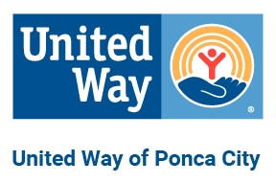
Top 10 Reasons for Supporting Your Community through United Way of Ponca City

Local Impact
1
- Donations are raised locally and are used locally to provide for the needs of citizens in our community.

Efficiency
2.
United Way combines the financial needs of many nonprofit organizations into one effort, eliminating multiple appeals wasteful duplication.

Accountability
3.
United Way ensures the contributor that agencies are spending donated dollars wisely through frequent review by volunteers and strict adherence to financial accountability practices.
4. Accessibility
Through the allocations process, United Way ensures that basic health and human services are available throughout Ponca City should you, your family, or your neighbor ever need them.
5. Dependability
United Way funded agencies rely on their assured allocation from United Way to budget and plan their services for the year. The United Way system also allows agencies to focus on providing services and keeps their overhead
costs low.

Flexibility
6.
United Way provides an alternative to government services for many of the people who fall between the cracks.

Deductibility
7.
All gifts are not only tax deductible, but also keep taxes down by keeping people off welfare, helping the disabled, reducing crime, delinquency, etc.

Simplicity
8.
The payroll deduction option available through workplace campaigns makes giving easy and convenient, enabling
individuals to make a difference all year long, and over time, make a more substantial investment in our community then they could by making a one-time gift.

9.

10.

Diversity
United Way brings local citizens from all walks of life together in the spirit of volunteerism by working to create a more caring and responsive community.

Keeping it local
Your donations to United Way of Ponca City can change lives and shapes our community by funding 11 programs. For a complete list of our Partner Agencies, visit us online at https://www.unitedwayponcacity.org/

The needs in Ponca City are greater now than ever before.
NOW is the time to LIVE UNITED. Join us today!

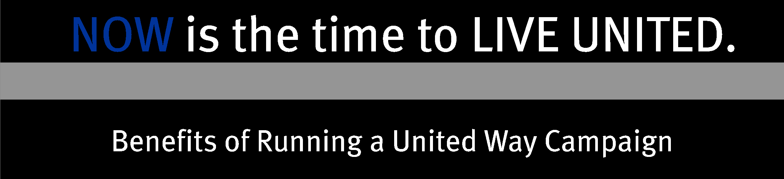
When you give through United Way, your donations go towards funding the most critical health and human services and improve the quality of life for residents right here in Ponca City.

But what are some of the other benefits to your company when you support United Way?

- Improved Customer Relations and Loyalty: Market research shows that customers are more likely to purchase goods and services from organizations that support their local community.

- Agency Education: Many people are unaware of the programs that our network of agencies provide to all residents in Ponca City. Running a campaign will allow your employees to learn about the resources available to them in our community.

- Community Volunteering Opportunities: United Way coordinates local volunteer opportunities for our partner agencies which gives your employees a hands-on opportunity to give back to our community!

- Community Relations/Enhanced Corporate Image: Supporting United Way shows that your
organization provides more than a product or service- it provides support for the local community as well.

- Improve Stakeholder Relations/Recognition: A visible interest in supporting the region's capacity to maintain a network of health and human services can enhance relationships with your stakeholders and other community leaders.

- Enhanced Employee Relations: Running a campaign can humanize the corporate machine as employees work to better their community instead of just the company. Participation in a campaign committee can help build teams of strong leaders within your company and boost morale as employees learn to set goals to achieve positive results.

- Financial Benefits: Companies and employees can receive tax deductions/credits for charitable gifts.

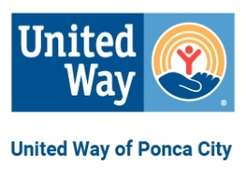

For more information about United Way of the Ponca City please visit us online at https://www.unitedwayponcacity.org/

